# Question 1

The company wants to know the optimized staffing recommendations for the business case described. Write the mathematical model for the deterministic optimization problem. Define and explain your decision variables, objective function and the constraint. (Hint: Use months of the year as the model timeline).

* Decision variables:

Decision variables are time equivalent of employee. Since there are two types of employees Full Time (FTE) and outsourced which works in different state and applications handles by them changes per month we have created two decision variables as below:

FTE-S,M

Outsourcing-S,M

where S = State, M =Month

* Objective Function:

Our objective is to minimize the cost of processing the application. It can be calculated by time equivalent of employee * salary of the employee

Min∑ -S,M (FTE-S,M ∗ FTE Salary -S,M + Outsourcing -S,M ∗ UnitOutsoucingCost-S,M)

* Constraints:

1. 40 insurance applications per month when he/she works 100% of the workdays.

Total demand -S,M == FTE -S,M ∗40∗S and month of outsourcing

1. States A and B have a regulatory restriction that the outsourced insurance applications cannot be more than 30% and 40% of the total number of applications for each month, respectively.

Outsourcing -S,M ≤ total_demand -S,M ∗0.30 for state A

Outsourcing -S,M ≤ total_demand -S,M ∗0.40 for state B

# Question 4

1. Use the solution of Q2 to create a stacked column chart that shows the percentage of applications processed by the staff and by the vendor for each month (%staff processed applications+ %vendor processed applications should add up to 100%).

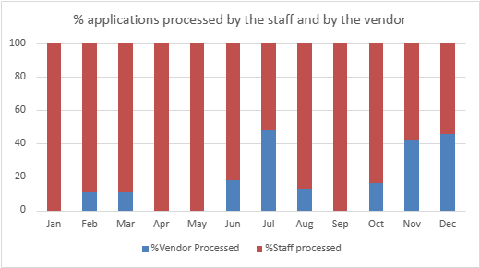

1. Create a graph to show how the cost per application increases with respect to any change in the parameters in your analysis. Hint: Use the cost per application that you calculate in Questions 2 and 3 (i.e., the best case, and the worst case).

